Digital Forensics
Ramy Naiem

Questions

1. What is the computer name?
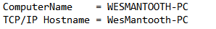
WESMANTOOTH-PC

2. What is its local time zone?
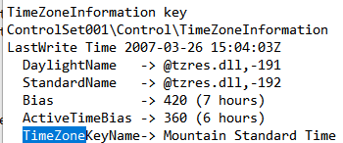
TimeZoneInformation key
ControlSet001\Control\TimeZoneInformation
LastWrite Time 2007-03-26 15:04:03Z
DaylightName -> @tzres.dll,-191
StandardName -> @tzres.dll,-192
Bias -> 420 (7 hours)
ActiveTimeBias -> 360 (6 hours)
TimeZoneKeyName-> Mountain Standard Time

3. What was its IP address?
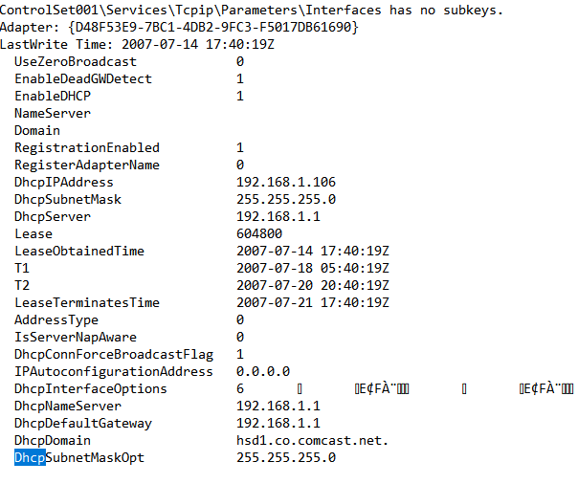
192.168.1.106

4. What is the DHCP domain?

hsd1.co.comcast.net

5. List 4 vendors of USB devices that have been connected on this system.

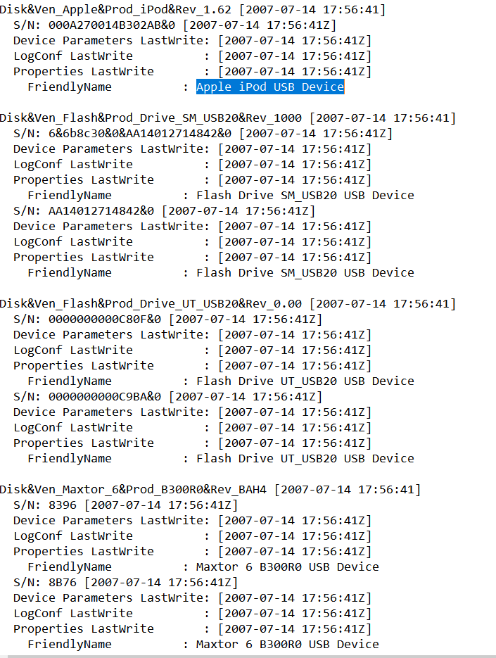

- Apple iPod USB Device
- Flash Drive SM_USB20 USB Device
- Maxtor 6 B300R0 USB Device
- SanDisk Cruzer Mini USB Device

6. What was last mounted as the G drive?
The ipod was the last mounted device to the G drive

7. What websites has the user visited in IE?
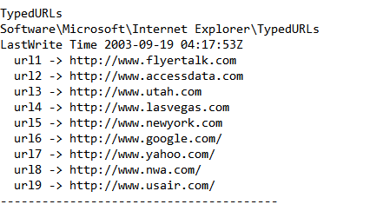
url1 -> http://www.flyertalk.com
url2 -> http://www.accessdata.com
url3 -> http://www.utah.com
url4 -> http://www.lasvegas.com
url5 -> http://www.newyork.com
url6 -> http://www.google.com/
url7 -> http://www.yahoo.com/
url8 -> http://www.nwa.com/
url9 -> http://www.usair.com/

8. What is the path to a PowerPoint presentation the user has opened?
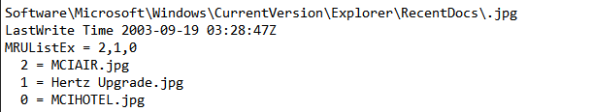
Software\Microsoft\Windows\CurrentVersion\Explorer\RecentDocs\.ppt
Introduction.ppt

9. What are the recent documents for this user?
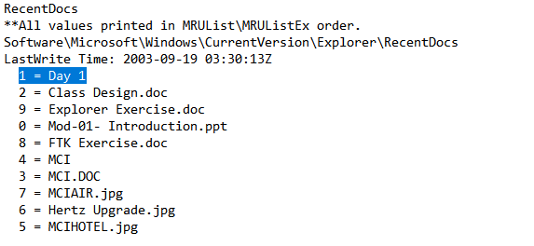
1 = Day 1
2 = Class Design.doc
9 = Explorer Exercise.doc
0 = Mod-01- Introduction.ppt
8 = FTK Exercise.doc
4 = MCI
3 = MCI.DOC
7 = MCIAIR.jpg
6 = Hertz Upgrade.jpg
5 = MCIHOTEL.jpg

10. List the commands last entered by the user, in order of most recent to oldest.
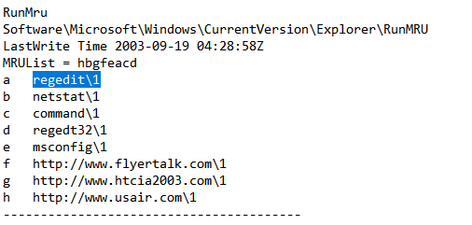
a regedit\1–
b netstat\1
c command\1
d regedt32\1
e msconfig\1
f http://www.flyertalk.com\1
g http://www.htcia2003.com\1
h http://www.usair.com\1

11. What strings did the user attempt to search the system for, searching by word or phrase in a file?

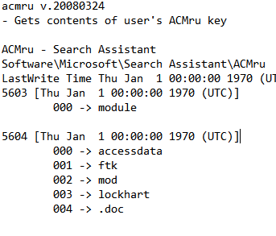
Software / Microsoft / Search Assistant / ACMru

12. What programs execute upon user login?

Software / Microsoft / Windows / Current Version / run

13. What would you expect to find as .Ink files in the recent folder on the computer? 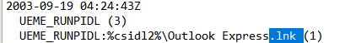
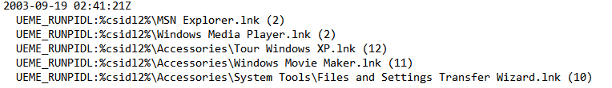
- UEME_RUNPIDL:%csidl2%\Outlook Express.lnk (1)
- UEME_RUNPIDL:%csidl2%\MSN Explorer.lnk (2)
- UEME_RUNPIDL:%csidl2%\Windows Media Player.lnk (2)
- UEME_RUNPIDL:%csidl2%\Accessories\Tour Windows XP.lnk (12)
- UEME_RUNPIDL:%csidl2%\Accessories\Windows Movie Maker.lnk (11)
- UEME_RUNPIDL:%csidl2%\Accessories\System Tools\Files and Settings Transfer Wizard.lnk

I would expect to see Outlook Express, MSN explorer, Windows Media Player, Tour Windows XP, Tour Windows Movie Maker and Files and Settings Transfer Wizard.

14. When was netstat.exe last run?
Fri Sep 19 04:29:06 2003

15. How many times has regedit. exe been run?
Regedit has been opened 11 times

Explanation:
1. I have used regripper 3.0 to transform the system file into a text file. I have used the search function in notepad to search for Computer Name and then I found the computer name.

2. The local time zone is Mountain Standard Time it was found with the System txt under time zone

¾ both the DHCP domain and the ip address where found in the same section system under interfaces

5. The usb devices were found under system / Controlset003 / enum / USBstor

6. The mounted drive was the ipod it can be found in system / mountedDevices

7. The websites that the user has found where 9 websites. It is located in the user file under software/Microsoft/internet explorer / typedurls

8. The user has opened the introduction power point and the path was in the recentDocs in User.dat.

9. The user has recently opened the following documents : Class Design, Explorer EWxecise, Mod-01- Introduction, FTK Exercise and MCI there where also jpg files that have been opened so I included them in the results.

10. I have used CTR + F to search for RunMRU in the software file.

